Worksheet No. 4

Student Name: ANINDITA DHAR UID: 25MCA20259
Branch: MCA (GENERAL) Section/Group: MCA- 1-A
Semester: II Date of Performance: 01/02/2026
Subject Name: Technical Training Subject Code: 25CAP-652

1.Aim/Overview of the practical:
To understand and implement iterative control structures in PostgreSQL conceptually, including FOR loops, WHILE loops, and basic LOOP constructs, for repeated execution of database logic.

2. Objectives:
- To understand why iteration is required in database programming
- To learn the purpose and behaviour of FOR, WHILE, and LOOP constructs
- To understand how repeated data processing is handled in databases
- To relate loop concepts to real-world batch processing scenarios
- To strengthen conceptual knowledge of procedural SQL used in enterprise systems

3. Input/Apparatus Used:
    - PostgreSQL
- pgAdmin

4. Practical / Experiment Steps
Pre-requisite Understanding
• Students should first understand that iterative control structures are executed inside PL/pgSQL blocks, not in normal SQL queries
• Students should create a table that stores multiple records so that loop execution over rows can be demonstrated
• The table should contain:
- A unique identifier
- A descriptive attribute (such as name or category)
- A numeric value to be processed repeatedly

4.Procedure/Algorithm/Code:

- Start the system and log in to the computer.

ii. Open PostgreSQL software.

iii. Create a table using the DDL command.

CREATE TABLE Employees (

emp_id SERIAL PRIMARY KEY,

emp_name VARCHAR(100),

salary NUMERIC(10,2)

);

iv. Insert records into the table named customer_orders.

INSERT INTO Employees VALUES('Rahul', 40000),

INSERT INTO Employees VALUES('Ankit', 52000),

INSERT INTO Employees VALUES('Priya', 60000),

INSERT INTO Employees VALUES('Neha', 35000),

INSERT INTO Employees VALUES('Aman', 70000);

vi. Display all records.

SELECT * FROM Employees;

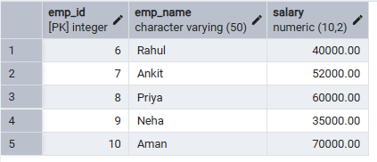

vii. (Step 1) FOR Loop – Simple Iteration

DO $$

BEGIN

FOR i IN 1..5 LOOP

RAISE NOTICE 'Iteration number: %', i;

END LOOP;

END $$.

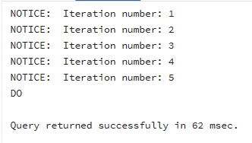

viii. (Step 2) FOR Loop with Query (Row-by-Row Processing)

DO $$

DECLARE

emp RECORD;

BEGIN

FOR emp IN SELECT emp_id, emp_name FROM Employees LOOP

RAISE NOTICE 'Employee ID: %, Name: %', emp.emp_id, emp.emp_name;

END LOOP;

END $$;

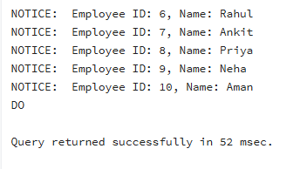

ix.(Step 3) WHILE Loop – Conditional Iteration

DO $$

DECLARE

counter INT := 1;

BEGIN

WHILE counter <= 5 LOOP

RAISE NOTICE 'Counter: %', counter;

counter := counter + 1;

END LOOP;

END $$;
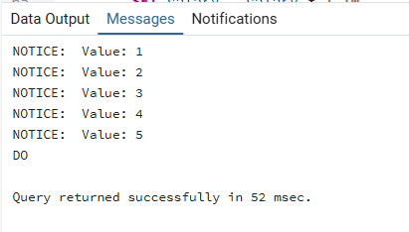
x. (Step 4) LOOP with EXIT WHEN
DO $$
DECLARE
x INT := 1;
BEGIN
LOOP
RAISE NOTICE 'Value: %', x;
x := x + 1;

EXIT WHEN x > 5;
END LOOP;
END $$.

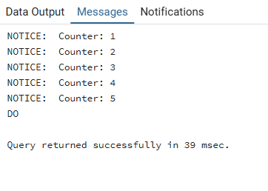
xi.(Step 5) Salary Increment Using FOR Loop
DO $$
DECLARE
emp RECORD;
BEGIN
FOR emp IN SELECT emp_id, salary FROM Employees LOOP
UPDATE employee
SET salary = salary * 1.10
WHERE emp_id = emp.emp_id;
END LOOP;
END $$;
select*from Employees;

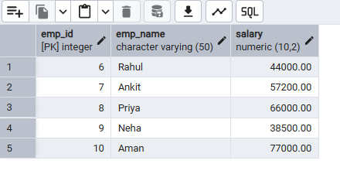

Step 6: Combining LOOP with IF Condition

DO $$
DECLARE
emp RECORD;
BEGIN
FOR emp IN SELECT emp_name, salary FROM Employees LOOP
IF emp. salary > 50000 THEN
RAISE NOTICE '% is a High Earner', emp.emp_name;
ELSE
RAISE NOTICE '% is a Regular Employee', emp.emp_name;
END IF;
END LOOP;
END $$;

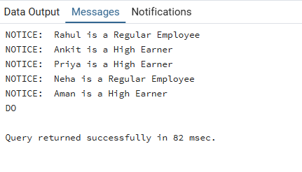
6. I/O Analysis (Input / Output)
Input:
• Employee or sample records inserted into a database table for iterative processing
• PL/pgSQL DO block containing procedural logic
• FOR loop constructs for fixed-range and query-based iteration
• WHILE loop with condition-based execution
• LOOP construct with explicit EXIT WHEN condition
• IF–ELSE conditions used inside loops for decision making
• UPDATE statements executed repeatedly within loop structures

Output:
- Repeated execution of SQL statements based on loop conditions
- Row-by-row processing of table records using FOR loops
- Conditional messages are displayed during each iteration
- Successful salary updates or value modifications through iterative logic
- Proper termination of loops based on defined conditions
- Correct execution of procedural SQL demonstrating iteration control

7. Learning Outcomes

- Understood the need for iterative control structures in database programming
- Learned the usage of FOR, WHILE, and LOOP constructs in PostgreSQL
- Gained knowledge of executing repeated logic using PL/pgSQL
- Understood row-by-row processing and conditional execution in the database
- Developed foundational skills for writing procedural SQL in real-world applications

